W : William to Cyril Lucraft : London © Ian Lucraft, for the Luc(k)raft One Name Study 1998

Presumed descent from William and Esther Newton of Broadclyst Note that these events have been reconstructed from a
see tree A1 : Nicholas Luccroft of Farringdon mixture of sources, including certificates, IGI, census an
family recollections etc., and are not all proven.

Nicholas Lucraft = Mary Thomas Toole = ?

possibly the child Nicholas baptised 9 Jan 1793, Broadclyst Parish Church possibly married to Mary Coombe
1850 Wine Cooper 5 Jan 1823, Shoreditch St Leonards
"A gentleman of Haberdashers Street" in Louisa's baptism record
Moulder

Louise Lucraft William Lucraft = Ann Toole

baptised 4 May 1824 1850 of Charlotte Place 1850 of Charlotte Place, no occupation listed
Shoreditch St Leonard's 1850 a Wine Cooper married 5 July 1850, Parish church of St James, Clerkenwell, both of full age
A clerk according to family memory witnesses Thomas Toole (his mark) and Rosina Toole

? William Lucraft = Mary Ann Bolton Thomas Samuel Lucraft

supposed child born Jun Q 1852 Islington born c 1853 Westminster/Islington ? born 2 Feb 1854, The Lying-in Hospital, St Lukes
1875 of 19 Norfolk Street
1875 Cooper married 7 March 1875 St Paul's Islington
1881 Census Grocer's Assistant

Edith Mary A Lucraft Annie Lucraft = William Walker Phyllis Kathleen Lucraft = George Toole Florence Lucraft = Alfred Newman William Thomas Lucraft = Daisy Alice Masterson

probable first child of ? born Sep Q 1877 born 19 Jun 1879 born ? Mar Q 1882 born 28 Aug 1885 born 28 Feb 1891
William and Mary Ann Islington Islington Holborn Goswell Road North Finchley
birth registered Sep Q 1875 Annie Elizabeth marr ? Mar Q 1901 marr Sep Q 1912 marr Mar/Jun Q 1912 Clerkenwell Holborn
Islington Holborn Holborn married 24 Jul 1915
1881 on Census with parents Lived Horley Finchley
aged 5
died c 1965 died c 1958 died 20 Jun 1966 died 4 Sep 1971
Salfords, Surrey Salfords, Surrey

Frederick William Nancy Frank Elsie Barbara = Albert Edith Cyril = Ann
Walker Walker Walker Newman Newman May Ward M William Elizabeth
Lucraft Lucraft Lucraft Knight

born 1 May 1919 born 30 Nov 1922 b 29 Nov 1929 born 1 Oct 1934
North Finchley North Finchley North Finchley West Knighton
"Edie" Dorset
marr 1946 URC Minister marr 24 Jul 1957
Dorchester
died 7 Nov 1976 died c 1927 1996 Dorchester

Anne-Marie = Paul Mark = Fiona
Poltorzycka Lucraft Lucraft Ovington

born 27 Jul 1959 born 28 Dec 1961
Southend Southend
marr 26 Apr 1985 Banker Barrister marr 15 Jun 1985
London Lindfield Sx. Walthamstow Colchester

Oliver Matthew Timothy
Lucraft Lucraft Lucraft

b 15 Oct 1988 b 18 Jan 1991 b 7 Mar 1995

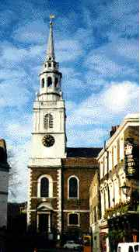

St James' Clerkenwell, where Willliam Lucraft
and Ann Toole married, 5th July 1850

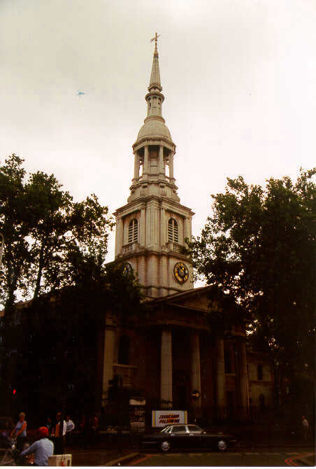

St Leonard's Shoreditch, , possible place of
marriage of Nicholas Lucraft and his wife Mary

