Note that these events have been reconstructed from a mixture of see descent from Benjamin Lucraft Trees A and B see Welch Family Tree C : George Seely Lucraft : Taunton - London
certificates, IGI, census and other data, and are not all proven © Ian Lucraft 1998 for the Luc(k)raft One Name Study

George Seely Lucraft = Amelia Welch Mary Ann Welch
Baptised 3 Nov 1831, St Mary's Taunton, son of Benjamin & Mary born c 1830, daughter of Edward Welch, (See Welch Tree) buried next to her sister's father-in-law Benjamin Lucraft
1851 Chair and Sofa Maker of 52 Brittania Row married 26 Nov 1851 St Paul's Islington, a Currier by trade.
died 28 Dec 1916 bur Abney Park next to father died 21 Mar 1920, buried Kirby Essex, stone in Abney Park

Mary Ann Lucraft = Henry Smithett George Seely Lucraft = Rebecca Edmonds Eliza Lucraft = Tom Tivendale Amelia Lucraft
b 1852 Islington born c 1850 born 1855 Islington born c 1856 Bloomsbury born 1857 Islington born 1860 Islington
marr 1876 Islington The Edmonds family built Edmonton marr 1882 Islington
Cabinet Maker marr 1876 St Pancras died unmarried
business at 79 City Road (Ella Edmonds and Emma Jackson witnessed GS' Will.
1886 at 37 Kyverdale Road, Stoke N Tony Benn's family took in one child when Rebecca widowed
died in a horse riding accident died 24 Jan 1937
died 23 Dec 1886, buried Highgate buried Highgate with husband
Henry Smithett = ? Millie Smithett = ? Tom Tivendale = ? Douglas Tivendale

George Edmonds = Edith Maria Herbert = Elizabeth Agnes Dolly = Fred Vernon Seely = Kate Rebie Ella = Alfred Reginald = Edith
Lucraft Crowther Lucraft Powell Lucraft Williams Lucraft Birchell Lucraft Davis Lucraft Wood
born 1877 Hackney born ca 1883 born 1878 Hackney of Wales b1881 Islington born 1880 Islington born 1885 Islington
1909 Cabinet Maker's family of Sewell & Crowther Furniture trade "Ella" called "Trottie" Shipping Agent
Manager of Travel Agents, Bishopsgate Metal Merchant in grew roses marr 1915 Hackney Worked for Nicholson's Gin marr 1915 Sherrif of London m 1913
22 Rectory Road Stoke N marr 23 Sep 1909 Hackney until 1939 marr 1916, Rochford Ex Gave Benjamin's chair Caterer Malden Sy Wiggin Richardson Rochford
Harecourt Congregational Worked for Herbert and to Herbert in lieu St John's Street Family on Q Mary Essex
died of Gas wounds St Paul's Road Islington 1926 moved to married him of a debt maiden voyage
from First World War of Dunwood House Westcliffe Both at Band of Hope
Paradise Row, Church St died 1950 at Harecourt Congs d.s.p.
Stoke Newington Westcliffe died 3 Jan 1967 Westcliffe
Rex Wood Jack Edmonds = Jane Peter George = Joyce
Lucraft Lucraft Griggs Sidney Lucraft Birch

"Reginald" b 1916 Edmonton b 1918 Edmonton b 1914 West Ham Shipping Agent Director of
1981 Bedford Ave 1981 Winchmore Hill Sewell and Crowther
owns bookcase
Leslie = Barbara E George N Phyllis¹ = Howard V = ²Patricia Masoko Jeffrey Baines = Eileen Florence
Thomas Lucraft Lucraft Turnbull Lucraft Ogate Lucraft Parsons
b 1916 Edmonton b 1914 Edmonton of Newcastle b 1916 Barnet b Long Island New York b 1918 Amersham
Band Leader of Japanese parents
married twice ? died as child divorced 1962 Composer marr 1973 California
died 1980 California 1988 North London
Ann Patricia Debbie
Lucraft Lucraft Lucraft

Elizabeth Kathleen Marjorie = Wallace Sybil = Terence Pamela = G Nigel Jeffrey = Penelope Susan = Peter
Joyce Dullis June Rogers Margaret O'Brien Jill Chamberlain Lucraft Jane Jane Hardy
Lucraft Lucraft Lucraft Lucraft Lucraft Ockleford Lucraft
"Betty" "Kay" of Windsor "Bunty"
b 1917 Kensington b 1919 Kensington b 1922 Kensington Dentist b 7 Oct 1926 b 1928 b 1952 London
First UK female Chemist Father was Shipbroker
Customs Officer steward to owns Ben's Chair marr 1950 marr 1950 1987 Furniture Maker marr 1980
London 1981 Soton. Q Victoria Shoeburyness 1980 Devon Westcliffe Appledore, Devon Dorset
Divorced
d 29 Aug 1998 d 22 June 1996

Susan B = ? Malcolm George Marie Crispin Rex
Thomas Thomas Jane James Hardy
Hardy Hardy

daughter son Peter Michael John = Helen Lesley - ? Richard = Mandy Frances Rebecca Benjamin
O'Brien O'Brien O'Brien Veronica Chamberlain Lucraft Lucraft Lucraft
Chamberlain
b 1950 b 1956 b 1962 b 1952 Westcliffe b 1956
Westcliffe Westcliffe Shoeburyness Reuters Reporter Sutton Coldfield
Doctor Author 1988
Penguin "Best of 1981 Dawlish
Russian Cookery" 1988 Brighton

Megan Isabelle Elizabeth daughter
O'Brien Chamberlain
b 12 May 1994

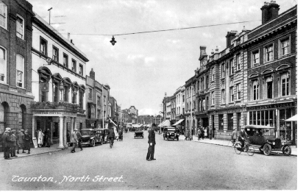
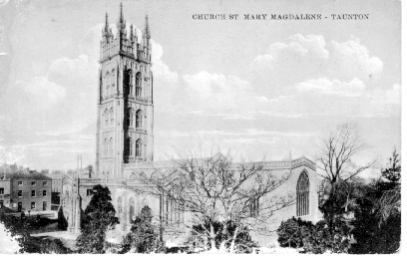
North Street, Taunton, where George Seely Lucraft St Mary Magdalene, Taunton, where Benjamin Lucraft had been married, lived with his parents from 1831 until 1833 and where his first son George Seely Lucraft was baptised 3 November1831.

